OPSC6311 POE Part 1

Members include:  
Aaron Adams St10376245 (Project Leader)  
Joel Mbaya ST10390852  
Kamvalethu Mdanjelwa ST10377628  
Neville Kalala ST10346082  
David Ayowa ST10368326

Research   
Three Personal Budget Apps:

## 1.

* - Vault22: This app is completely free and trusted by over 180,000 South Africans. It offers a user-friendly interface, powerful features, and the ability to link multiple bank accounts, credit cards, store cards, loans, and investments. ¹
* - Spendee: This app provides a detailed breakdown of spending patterns and allows secure linking of investment accounts. It offers a free version, as well as premium options with additional features.
* - YNAB (You Need a Budget): This app follows the zero-based budgeting system, helping you plan for your financial decisions. It offers features like linking checking and savings accounts, credit cards, and loans, as well as educational resources. ²

These apps can help you track your spending, create a personalized budget, and achieve your financial goals.

## 2.

1. 22Seven

Description:

22Seven is a free budgeting app that helps users track their income and expenses, set budgets, and receive personalized financial recommendations.

Features:

- Links to multiple bank accounts, credit cards, and investments

- Automatic expense categorization

- Budgeting and forecasting tools

- Investment tracking and analysis

- Bill tracking and reminders

- Free to use, with no hidden fees

Pros:

- User-friendly interface

- Comprehensive financial overview

- Personalized financial recommendations

Cons:

- Limited investment options

- No web-based platform (mobile-only)

2. Spendee

Description:

Spendee is a budgeting app that allows users to track their expenses, create budgets, and set financial goals.

Features:

- Expense tracking and categorization

- Budgeting and forecasting tools

- Financial goal setting

- Automatic expense tracking

- Receipt scanning and storage

- Available on both mobile and web platforms

Pros:

- Easy expense tracking

- Customizable budgets and financial goals

- Receipt scanning and storage

Cons:

- Limited investment tracking

- Premium features require subscription

3. YNAB (You Need a Budget)

Description:

YNAB is a budgeting app that helps users manage their finances by assigning jobs to every dollar they earn.

Features:

- Zero-based budgeting

- Automatic expense tracking

- Investment tracking and analysis

- Bill tracking and reminders

- Financial goal-setting

- Available on both mobile and web platforms

Pros:

- Effective budgeting methodology

- Comprehensive financial tracking

- Investment tracking and analysis

Cons:

- Steeper learning curve

- Subscription-based (offers free trial)

## 3.

**INFOGRAPHIC:**

22Seven:

PROS:

* User-Friendly interface
* Comprehensive financial overview
* Personalized financial recommendations

CONS:

* Limited investment options
* No web-based platform(mobile-only)

Spendee:

PROS:

* Easy expense tracking
* Customizable budgets and financial goals
* Receipt scanning and storage

CONS

* Limited Investments Tracking
* Premium features require subscription

YNAB(You Need a Budget) :

PROS

* Effective Budgeting methodology
* Comprehensive financial tracking
* Investment tracking and analysis

CONS

* Steeper learning Curve
* Subscription based (Offers free trail)

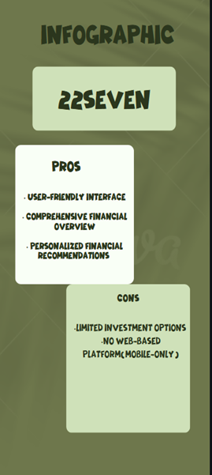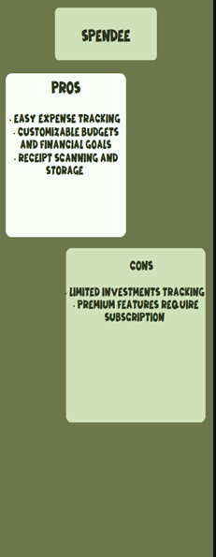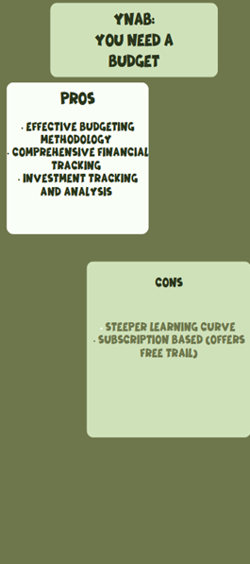

## 4.

1. 22Seven

1. 1. Automated expense categorization: 22Seven uses machine learning to automatically categorize transactions, making it easier to track expenses.
2. 2. Personalized financial recommendations: The app provides tailored advice based on users' financial data and goals.
3. 3. Investment tracking and analysis: 22Seven allows users to track their investments and provides detailed analysis to help inform investment decisions.
4. 4. Bill tracking and reminders: The app sends reminders for upcoming bills, ensuring users never miss a payment.
5. 5. Free to use, with no hidden fees: 22Seven is free, with no hidden fees or charges.

2. Spendee

1. 1. Automatic expense tracking: Spendee's automatic expense tracking feature allows users to easily monitor their spending.
2. 2. Receipt scanning and storage: Users can scan receipts and store them within the app, making it easy to track expenses and claim reimbursements.
3. 3. Customizable budgets and financial goals: Spendee allows users to set personalized budgets and financial goals, helping them stay on track.
4. 4. Financial insights and analysis: The app provides detailed financial insights and analysis, enabling users to make informed decisions.
5. 5. Available on both mobile and web platforms: Spendee is accessible on both mobile devices and web platforms, ensuring users can access their financial data anywhere.

3. YNAB (You Need a Budget)

1. 1. Zero-based budgeting: YNAB's zero-based budgeting approach helps users assign jobs to every dollar they earn, ensuring they make the most of their money.
2. 2. Automated savings and investment tracking: The app allows users to track their savings and investments, making it easier to achieve long-term financial goals.
3. 3. Financial goal setting: YNAB enables users to set and work towards specific financial goals, such as saving for a down payment on a house.
4. 4. Bill tracking and reminders: The app sends reminders for upcoming bills, ensuring users never miss a payment.
5. 5. Investment tracking and analysis: YNAB allows users to track their investments and provides detailed analysis to help inform investment decisions.

## 5.

Conclusion:

Each of the three well-known budgeting apps—22Seven, Spendee, and YNAB—offers useful capabilities for managing personal finances, according to an analysis. A web-based platform and investment tracking are absent from 22Seven, but its free-to-use concept, automated spending classification, and tailored financial advice make it stand out. Spendee offers a cross-platform interface, adjustable budgets, and receipt scanning, but its premium features require a subscription. With its zero-based budgeting methodology, YNAB provides comprehensive financial tracking and investment analysis; nevertheless, it has a monthly charge and a learning curve.

The greatest features from these systems, such automated spending tracking, personalized financial insights, budget customization, and investment tracking, will be incorporated into our mobile budgeting software while maintaining an intuitive user experience. Our software will offer a complete, easily accessible, and effective financial management solution that is customized to users' needs by tackling common constraints including restricted investment alternatives and subscription hurdles.

# References

* *Vault22*. (n.d.). <https://www.vault22.io/>
* SPENDEE a.s. www.spendee.com. (n.d.). *Money Manager & Budget Planner | Spendee*. Copyright 2025 SPENDEE a.s. | All Rights Reserved. <https://www.spendee.com/>
* *YNAB*. (n.d.). <https://www.ynab.com/>